Image Processing Related to change detection.

# Change Detection techniques and Algorithms.

MacLeod and Congalton (1998) described four important aspects of change detection for monitoring natural resources: detecting if a change has occurred, identifying the nature of the change, measuring the areal extent of the change, and assessing the spatial pattern of the change. Successfully implementing a change detection analysis using remotely sensed data requires careful considerations of the remote sensor system, environmental characteristics and image processing methods. Conversion of digital numbers to radiance or surface reflectance is a requirement for quantitative analyses of multi-temporal images. Before implementing change detection analysis, the following conditions must be satisfied: (1) precise registration of multi-temporal images; (2) precise radiometric and atmospheric calibration or normalization between multi-temporal images; (3) similar phenological states between multi-temporal images; and (4) selection of the same spatial and spectral resolution images if possible. Many kinds of remote sensing data are available for change detection applications. Historically, Landsat Multi-Spectral Scanner (MSS), TM, SPOT, AVHRR, radar and aerial photographs are the most common data sources, but new sensors such as Moderate Resolution Imaging Spectroradiometer (MODIS) and Advanced Spaceborne Thermal Emission and Reflection Radiometer (ASTER) are becoming important. When selecting remote sensing data for change detection applications, it is important to use the same sensor, same radiometric and spatial resolution data with anniversary or very near anniversary acquisition dates in order to eliminate the effects of external sources such as Sun angle, seasonal and phenological differences. Determination of change direction is also important in selecting appropriate change detection techniques. Some techniques such as image differencing can only provide change/non-change information, while some techniques such as post classification comparison can provide a complete matrix of change directions.

The classification category includes post-classification comparison, spectral temporal combined analysis, expectation–maximization algorithm (EM) change Change detection techniques 2383 detection, unsupervised change detection, hybrid change detection, and ANN. These methods are based on the classified images, in which the quality and quantity of training sample data are crucial to produce good quality classification results. The major advantage of these methods is the capability of providing a matrix of change information and reducing external impact from atmospheric and environmental differences between the multi-temporal images. However, selecting high-quality and sufficiently numerous training sample sets for image classification is often difficult, in particular for historical image data classification. The time consuming and difficult task of producing highly accurate classifications often leads to unsatisfactory change detection results, especially when high-quality training Ssample data are not available.

These classification methods often require a large amount of training sample data for supervised or unsupervised classification of image data. Post-classification comparison is a common approach used for change detection in practice, but the difficulty in classifying historical image data often seriously affects the change detection results. The hybrid change detection method combines the advantages of the threshold and classification methods. The threshold methods such as image differencing are often used to detect the changed areas, then classification methods are used to classify and analyse detected change areas using the threshold method. The spectral–temporal combined change detection method and unsupervised change detection method are used less frequently in practice due to the difficulty in identifying and labelling change trajectories. The EM method is not commonly used due to the complexity of estimating a priori joint class probability. The ANN approach can probably provide better change detection results when the land-cover classes are not normally distributed. In recent years, the research on ANN methods for change detection has attracted increasing attention.

**Image registration** is the process of transforming different sets of data into one coordinate system. Data may be multiple photographs, data from different sensors, times, depths, or viewpoints.[[1]](https://en.wikipedia.org/wiki/Image_registration#cite_note-1) It is used in [computer vision](https://en.wikipedia.org/wiki/Computer_vision), [medical imaging](https://en.wikipedia.org/wiki/Medical_imaging),[[2]](https://en.wikipedia.org/wiki/Image_registration#cite_note-2) military [automatic target recognition](https://en.wikipedia.org/wiki/Automatic_target_recognition), and compiling and analyzing images and data from satellites. Registration is necessary in order to be able to compare or integrate the data obtained from these different measurements. (https://en.wikipedia.org/wiki/Image_registration, n.d.)

# Threshold Selection

Many change detection algorithms require selection of thresholds to differentiate change from no-change areas. Two methods are often used for selection of thresholds: (1) interactive procedure or manual trial-and-error procedure—an analyst interactively adjusts the thresholds and evaluates the resulting image until satisfied; and (2) statistical measures— selection of a suitable standard deviation from a class mean. The disadvantages of the threshold technique are that: (1) the resulting differences might include external influences caused by atmospheric conditions, Sun angles, soil moistures and phenological differences in addition to true land-cover change; and (2) the threshold is highly subjective and scene-dependent, depending on the familiarity with the study area and the analyst’s skill. In order to improve the change detection results, Metternicht (1999) used fuzzy set and fuzzy membership functions to replace the thresholds. Bruzzone and Ferna´ndez Prieto proposed automatic analyses based on the Bayes rule for minimum error and a minimum-cost thresholding technique to determine the threshold that minimizes the overall change detection error probability. An adaptive parcel-based technique was also proposed to reduce the effects of noise produced in the unsupervised change detections. However, because of the simplicity and intuitiveness in determination of thresholds, the threshold method is still the most extensively applied in detecting binary change and no-change information even though the disadvantages of selecting suitable thresholds exist. (change detection techniques_IJRS_2004.pdf)

# Water level detection.

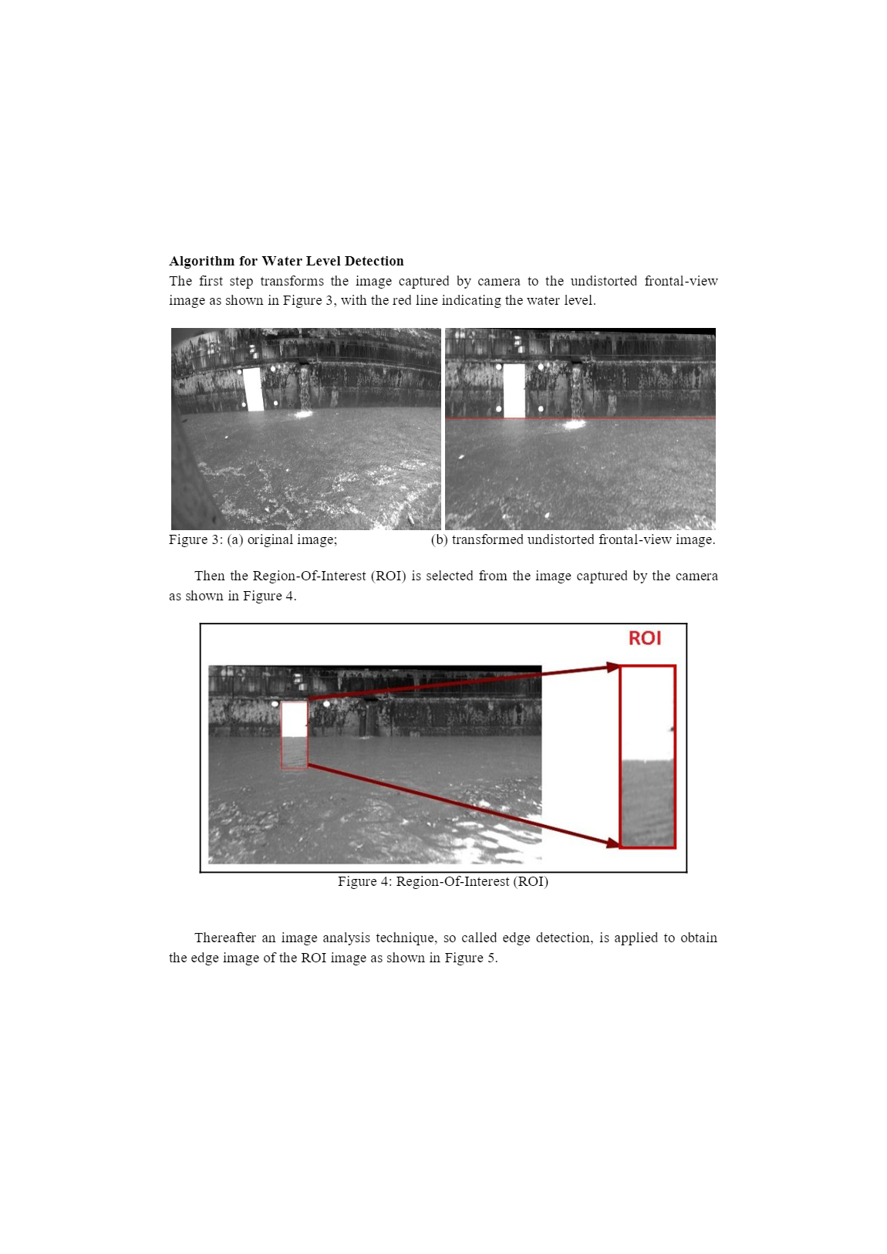

Thereafter an image analysis technique, so called edge detection, is applied to obtain the edge image of the ROI image as shown in Figure 5.

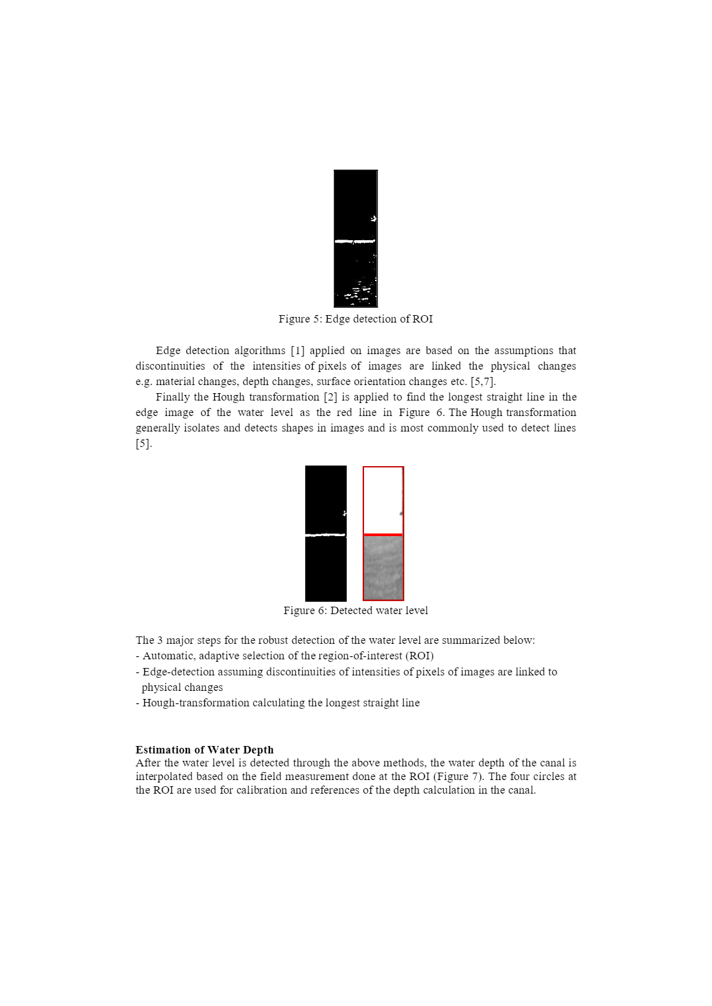

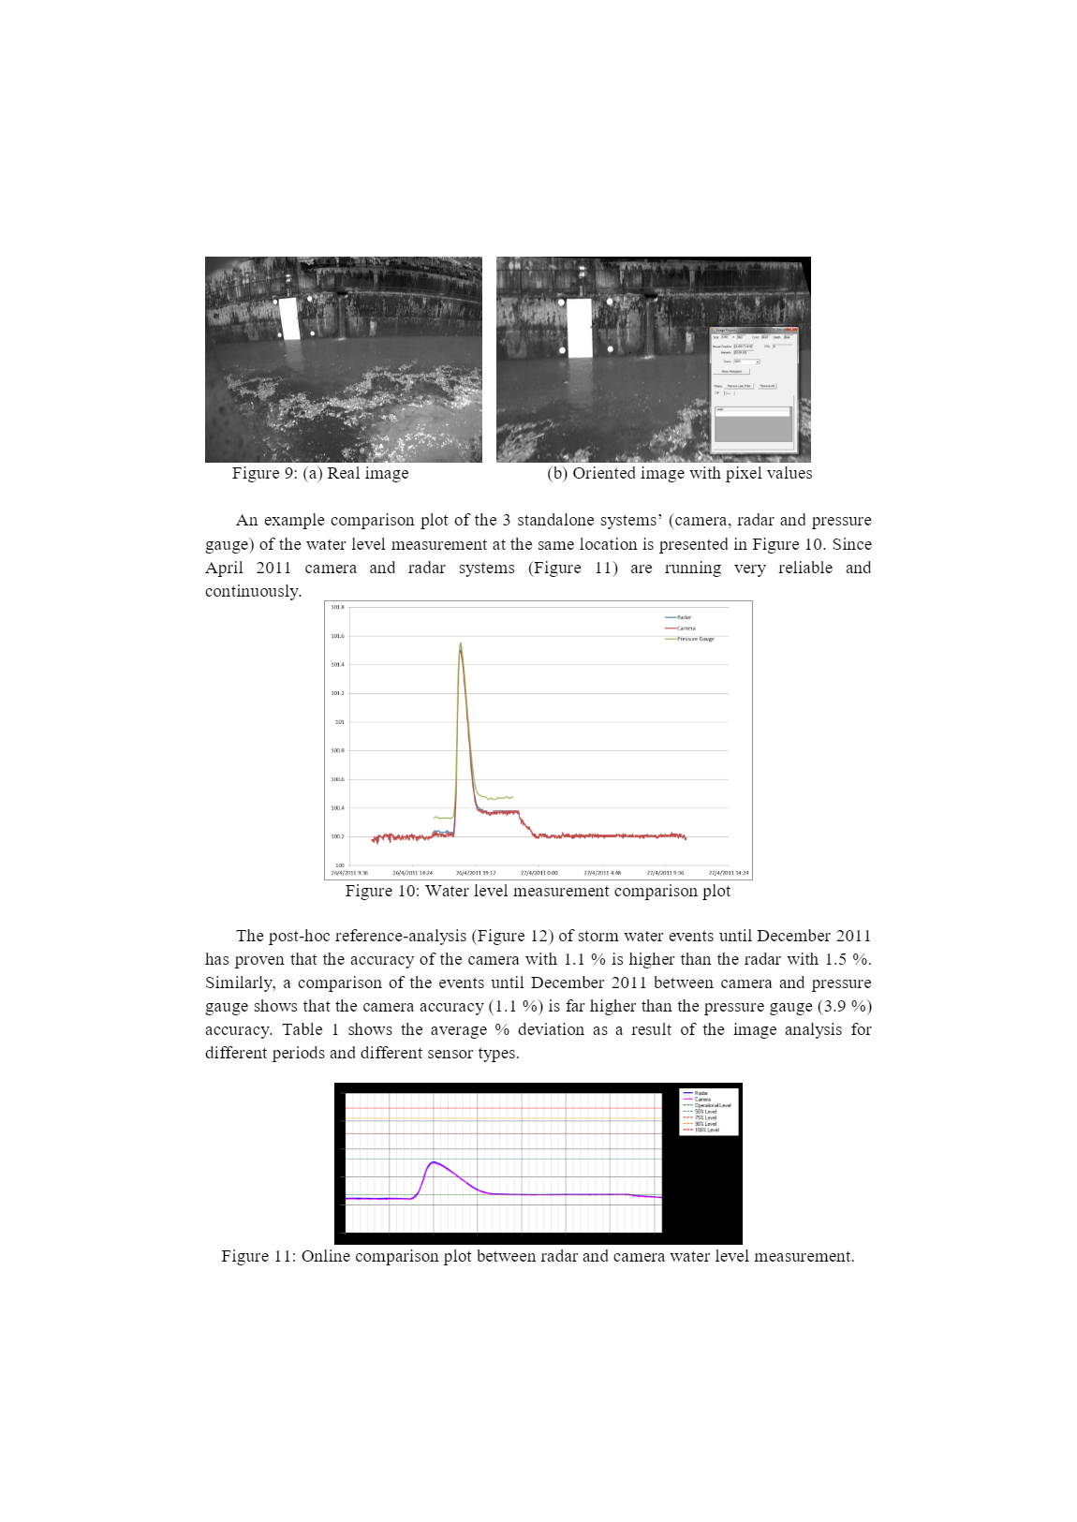

(https://www.researchgate.net/publication/262337135_Enhanced_water-level_detection_by_image_processing)

# Liquid level detection using gray scale(monochrome) image.

1. Laboratory purpose Project

**Image calibration**, also known as reduction, fixes tiny defects in the camera sensor and optical system. **Image calibration** may sound like a boring topic, but proper **calibration** is of the utmost importance in producing good quality **images**. Despite many years of refinement, no electronic **imaging** device is perfect. (https://diffractionlimited.com/help/maximdl/Calibration.htm, n.d.)

Image calibration is neglected for less sophisticated equipment but is important when it comes to analyzing the images from a telescope or such devices. Like in this case also. Because very minute changes in the liquid level is also needed to be detected. So, Image calibration is necessary in such cases.

[Edge detection](https://in.mathworks.com/products/image.html) is an image processing technique for finding the boundaries of objects within images. It works by detecting discontinuities in brightness. Edge detection is used for [image segmentation](https://in.mathworks.com/discovery/image-segmentation.html) and data extraction in areas such as image processing, computer vision, and machine vision.

Common [edge detection algorithms](https://in.mathworks.com/help/images/ref/edge.html) include Sobel, Canny, Prewitt, Roberts, and [fuzzy logic](https://in.mathworks.com/products/fuzzy-logic.html) methods.( <https://in.mathworks.com/discovery/edge-detection.html>)

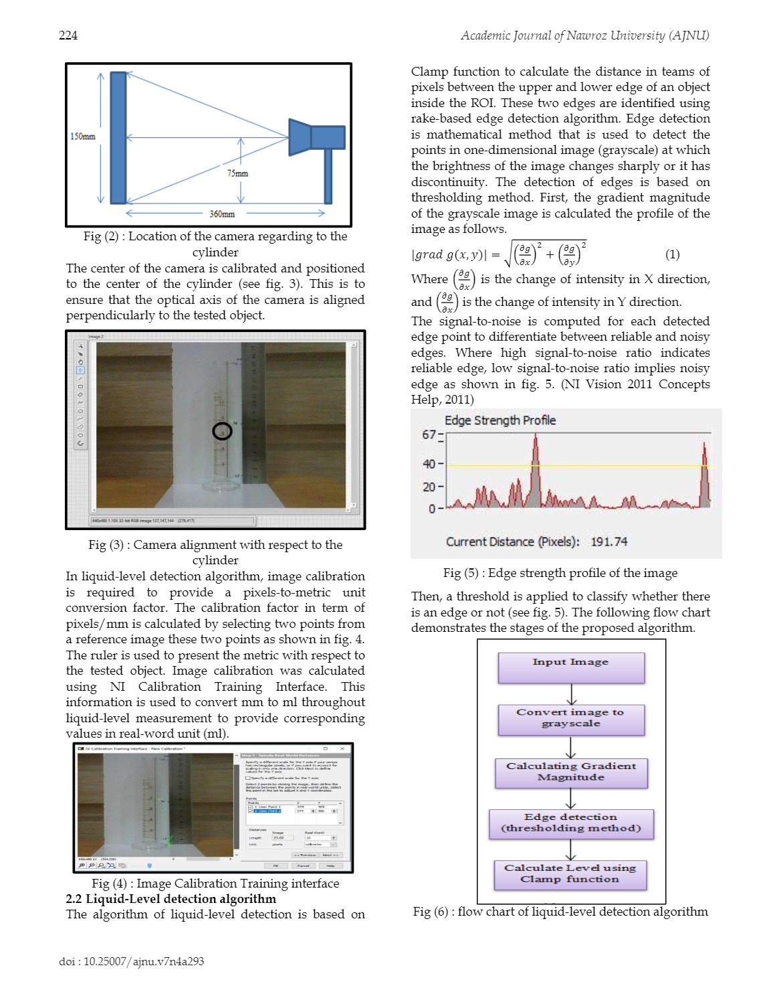

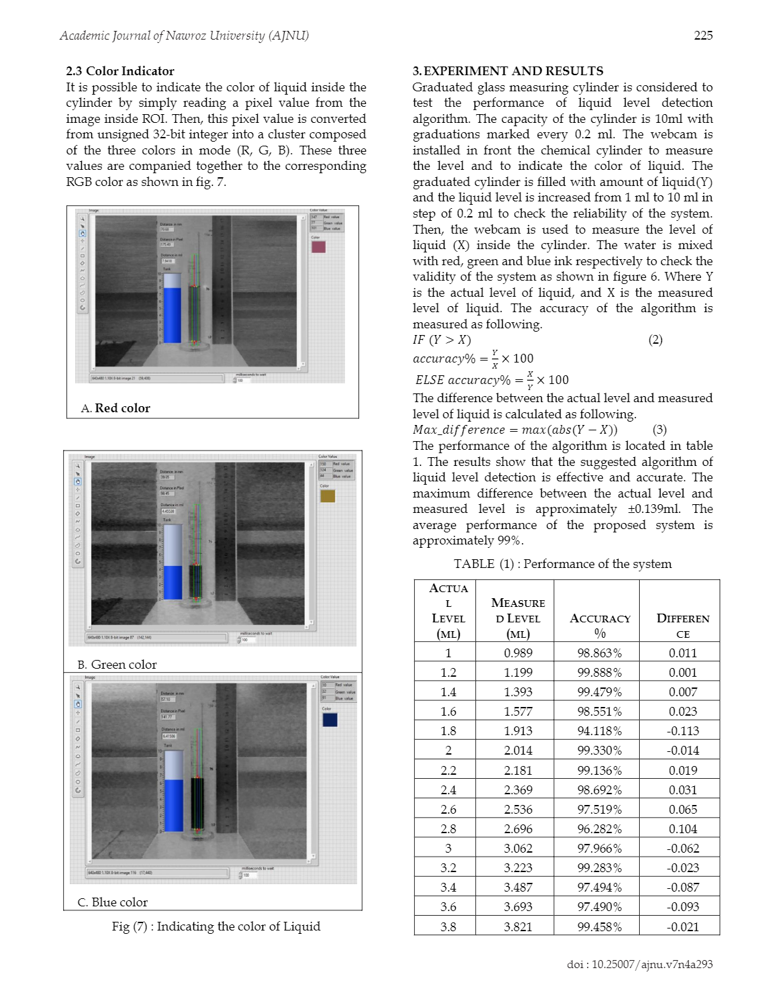

<https://www.researchgate.net/publication/326345616_Real-time_Liquid_Level_and_color_Detection_system_using_Image_Processing>

1. Japanese paper <https://patents.google.com/patent/JP4001162B2/en>

 When an object to be measured is detected by conventional monochrome grayscale image processing, edge extraction processing is often performed. Further, in recent years, in order to perform high-precision processing by the applicant, for each point constituting an edge on an image (hereinafter referred to as “edge point”), the density is determined based on the density difference in the horizontal direction and the vertical direction. It has been proposed to obtain angle data representing the gradient direction (hereinafter referred to as “edge code”).

 For example, when extracting an object having a predetermined contour shape, a reference distribution pattern of the edge code is registered in advance using an image of the object model, and the reference A region where the edge code is distributed in a state close to the distribution pattern is extracted. When detecting a linear object, an edge code is used to specify an edge point constituting the outline of the object, and then a line segment is set along a direction orthogonal to the direction of the edge code.

On the other hand, a color image generally has a configuration in which R, G, and B image data are combined. Therefore, when processing using an edge code is performed, it is necessary to convert the color image data into monochrome grayscale image data. there were.

However, in order to correctly reflect the direction of the color change in the edge code, it is necessary to perform conversion processing in which various colors are represented by different densities. There is a problem that it takes time.  
For this reason, it is necessary to consider a method for applying an edge code calculation method for a monochrome image to a color image.

 An edge code in a monochrome grayscale image represents the direction in which the density changes (density gradient direction). In a color image, an edge is generated due to a large change in color. Therefore, the direction of the color change is referred to as an edge code. This is considered appropriate. That is, in monochrome grayscale image processing, the amount of change in density is obtained for each of the horizontal direction and the vertical direction, and the edge code is calculated from these amounts of change. In color image processing, instead of the amount of change in density. It is considered that the amount of color change (color difference) in each of the horizontal and vertical directions should be obtained.

Here, a method of calculating the color difference will be described using a specific example.  
For example, when colors are represented by parameters of the three primary colors of R, G, and B (hereinafter referred to as “color parameters”), each color has a Euclidean space (hereinafter, referred to as “axis”) with each color parameter as an axis. It is plotted at one point in the “color space”. The color difference is expressed as a distance between two points in this color space.

  For example, as shown in FIG. 9, in an image in which an XY coordinate system is set in which the horizontal direction is the X axis and the vertical direction is the Y axis, the image data of two adjacent pixels are respectively (Ra, Ga, Ba). Assuming (Rb, Gb, Bb), these colors are plotted at points A and B corresponding to the image data in the color space. In this case, the color difference CD between the pixels is obtained by the following equation [1].

  According to the above, in the color image, it seems that the color difference may be obtained by using the above equation [1] instead of the density difference for each of the X and Y directions. However, since the value obtained by the above equation [1] is always a positive value, the calculated edge code does not correctly reflect the color change.

The above problem will be described with reference to FIGS. First, FIG. 10 shows a coordinate system for specifying the direction of color change.  
In conventional monochrome grayscale image processing, a density difference having a positive or negative value can be obtained in either X or Y direction. Therefore, the origin O of this coordinate system is made to correspond to an edge point, and the X, Y By setting a combined vector of vectors based on the density difference in each direction, it is possible to correctly represent the direction in which the density changes at the edge point. That is, the edge code obtained from the monochrome grayscale image is considered to be distributed in all quadrants of the XY coordinate system of FIG. On the other hand, since the color difference in the case of a color image is 0 or a positive value, the edge code is limited to the range of the first quadrant

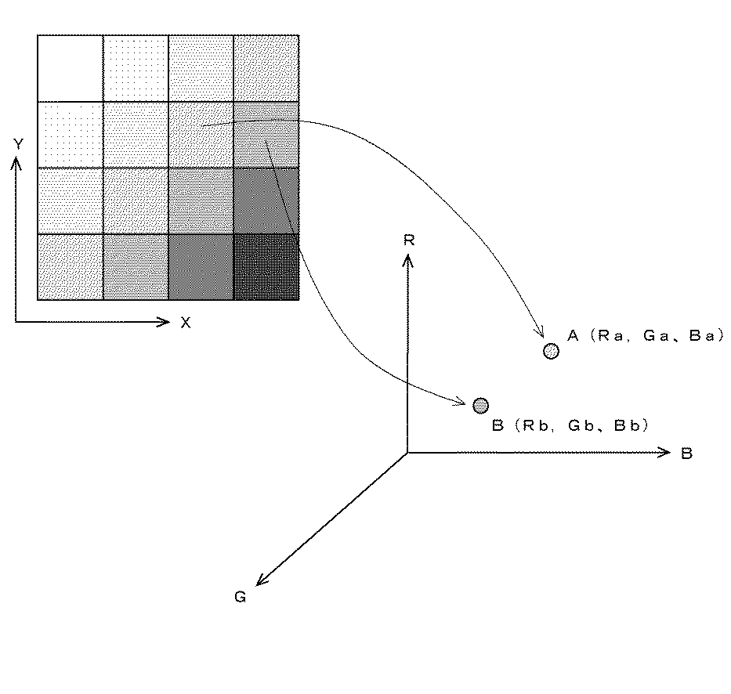

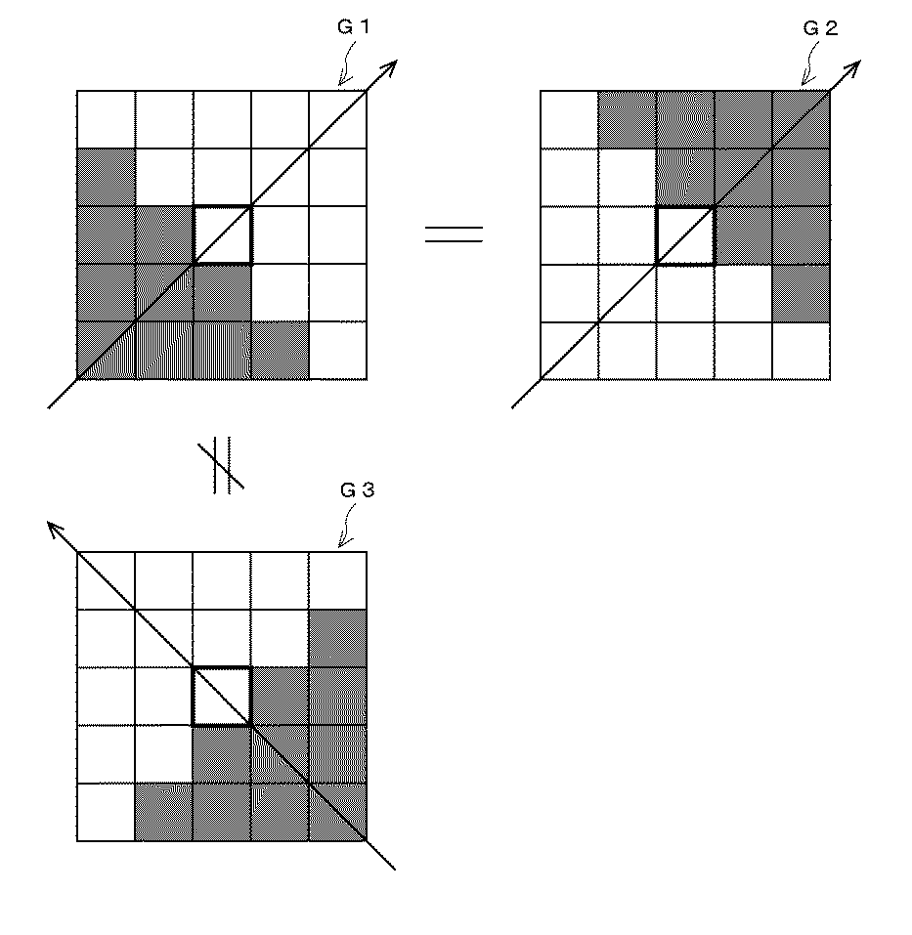

# Image Segmentation

Several algorithms and techniques for image segmentation have been developed over the years using domain-specific knowledge to effectively solve segmentation problems in that specific application area.  These applications include medical imaging, automated driving, video surveillance, and machine vision.

Image segmentation involves converting an image into a collection of regions of pixels that are represented by a mask or a labeled image. By dividing an image into segments, you can process only the important segments of the image instead of processing the entire image.

A common technique is to look for abrupt discontinuities in pixel values, which typically indicate edges that define a region.

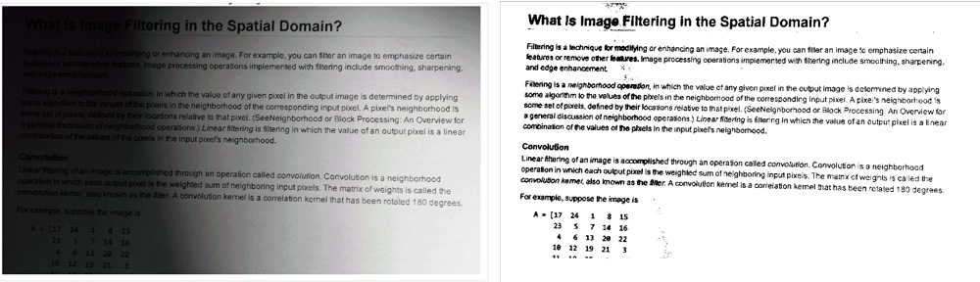

Using thresholding to convert to a binary image to improve the legibility of the text in an image.

Another common approach is to detect similarities in the regions of an image. Some techniques that follow this approach are region growing, clustering, and thresholding.

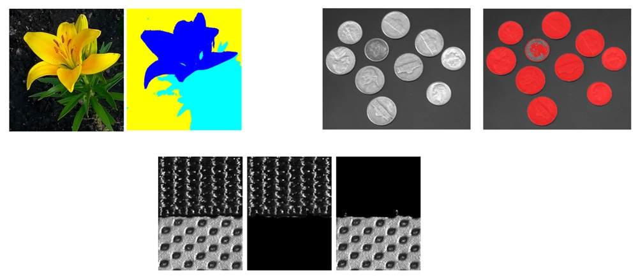

(<https://in.mathworks.com/discovery/image-segmentation.html>)

# Fuzzy logic for image processing (using MATLAB)

### Import RGB Image and Convert to Grayscale

### Convert Image to Double-Precision Data

The evalfis function for evaluating fuzzy inference systems supports only single-precision and double-precision data. Therefore, convert Igray to a double array using the [im2double](https://in.mathworks.com/help/matlab/ref/im2double.html) function.

### Obtain Image Gradient

The fuzzy logic edge-detection algorithm for this example relies on the image gradient to locate breaks in uniform regions. Calculate the image gradient along the x-axis and y-axis.

Gx and Gy are simple gradient filters. To obtain a matrix containing the x-axis gradients of I, you convolve I with Gx using the [conv2](https://in.mathworks.com/help/matlab/ref/conv2.html) function. The gradient values are in the [-1 1] range. Similarly, to obtain the y-axis gradients of I, convolve I with Gy. Plot the image gradients.

### Define Fuzzy Inference System (FIS) for Edge Detection

Create a fuzzy inference system (FIS) for edge detection, edgeFIS.

Specify the image gradients, Ix and Iy, as the inputs of edgeFIS.

Specify a zero-mean Gaussian membership function for each input. If the gradient value for a pixel is 0, then it belongs to the zero membership function with a degree of 1.

sx and sy specify the standard deviation for the zero membership function for the Ix and Iy inputs. To adjust the edge detector performance, you can change the values of sx and sy. Increasing the values makes the algorithm less sensitive to the edges in the image and decreases the intensity of the detected edges.

Specify the intensity of the edge-detected image as an output of edgeFIS.

As you can with sx and sy, you can change the values of wa, wb, wc, ba, bb, and bc to adjust the edge detector performance. The triplets specify the start, peak, and end of the triangles of the membership functions. These parameters influence the intensity of the detected edges.

Plot the membership functions of the inputs and outputs of edgeFIS.

### Specify FIS Rules

Add rules to make a pixel white if it belongs to a uniform region and black otherwise. A pixel is in a uniform region when the image gradient is zero in both directions. If either direction has a nonzero gradient, then the pixel is on an edge.

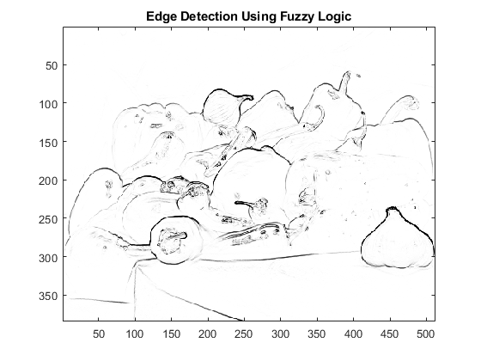

(<https://in.mathworks.com/help/fuzzy/fuzzy-logic-image-processing.html>)

# Digital Image Processing. (<https://www.sciencedirect.com/science/article/pii/S187770581105483X>)

At present, the level measurement is widely used in industry. As for the dynamical transportation and transmission of all kinds of raw materials and finished products in each production process, the quantity of material in the container needs to be known in production anytime and anywhere and if the blocked transportation happens, therefore, the concept of level measurement technology is proposed in industrial automation.

Digital image processing technology is a relatively new technology, which is new developing field of computer applications when the development of digital computers developed to a certain level in fifties. Transfer the image into a form of data matrix and store them in the computer, or show the application on computer, but also process series of images such as strengthening, deletion, addition etc. Today the application fields of digital image processing technology are fairly broad. The main applying technologies are the image input and output technology, image analysis, transformation pretreatment technology, image recognition and extraction technology for relevant information of image feature. Digital image technology has a further development, progress and improvement till sixties and seventies. The involve fields are increasing and extending, this paper mainly introduces the digital image technology of level measurement and control system

Digital image processing technology mainly focus on image processing technology, and the main measuring parameters of level measurement and measurement is measured by material surface area. Therefore, the precision of level measurement for the image processing of materials surface is very important; specifically include the following two aspects[1].

* 1. Image segmentation

The process of image segmentation means that separate the main target from the sub-body background of the image. The simplest and basic method of image segmentation is to set a threshold value at first, and then convert. The grey grade of pixel greater than threshold value is set to 1, and less than the threshold value is set to 0. So a multi-grey grade image is changed into binary image. And this method is called simple threshold method. This method is simple, and the application is wider, but it is not much used for level measurement. Due to at different altitude and under the influence of various factors such as the atmosphere, image grey values of material are different. Therefore, there will be a big error by using the simple threshold value.

Its main principles are that image is divided into several blocks, among of each there are 50% overlaps and the size is 64 by 64. And then each block do histogram separately. If the histogram shows obvious bimodal features, the simple threshold method will be utilized directly. As the other threshold values will be obtained by surrounding pixel interpolation values to confirm all threshold values by 64 by 64 blocks; then followed by quadratic interpolation values to confirm threshold values by 32 by 32 blocks, and so on, until each block has its own threshold value. As to specific performance, please refer to Figure 1. Obtain the image of post-segmentation by this way

* 1. Area estimation

After describing image segmentation, we’ll begin to estimate the surface area of materials in order to prepare following accuracy calculation. The surface image of materials by post-segmentation contains two elements, namely black background on behalf of container surface and white objective on behalf of materials. Now we make the position for "0" and "1". "1" means materials and "0" means background. The quantities of all "1" can estimate the surface area of materials by statistics of binary image, and add section area of container, the formula H≈H0(S/S0) could be used to calculate height of level.

CCD camera technology and image segmentation technique are two parallel technology concepts. There is no intersection; it can also be applied to the level measurement system. Obtain the image by using CCD cameras to shoot the material surface, through computer digitization, and image processing.

# Water Level Detection under a bridge(<https://ieeexplore.ieee.org/document/6746801>)

Abstarct-In this paper, we present two types of the real-time

water monitoring system using the image processing

technology, the water level recognition and the surface velocity

recognition. According to the bridge failure investigation,

floods in the river often pose potential risk to bridges, and

scouring could undermine the pier foundation and cause the

structures to collapse. It is very important to develop

monitoring techniques for bridge safety in the field. In this

study, we installed two high-resolution cameras on the in-situ

bridge site to get the real-time water level and surface velocity

image. For the water level recognition, we use the image

processing techniques of the image binarization, character

recognition, and water line detection. For the surface velocity

recognition, the proposed system apply the PIV(Particle Image

Velocimetry, PIV) method to obtain the recognition of the

water surface velocity by the cross correlation analysis. Finally,

the proposed systems are used to record and measure the

variations of the water level and surface velocity for a period of

three days. The good results show that the proposed systems

have potential to provide real-time information of water level

and surface velocity during flood periods.

This section presents an image processing method to recognize the water level in Feitsui reservoir. Figure 2 is the flowchart for recognition of the water level. First, the high-resolution camera beside the dam can capture images with the water gauge and water line. Second, we can interpolate the water level according to the detection of the water line and water gauge.



*A. Detect the Water Line By Thresholding*

There may be many ways to recognize the water line, however, some of them may not be suitable for detecting the water line under the field conditions. For instance, we tried to measure the water line by detecting the uneven luminance; but because of the reflection of ruler on the water surface which also generates the uneven luminance, and the threshold value can’t be found appropriately; In addition, we also tried to use motion detection method to split the foreground and background; but due to the shake of camera during the typhoon periods, the method is not suitable for this environment. Finally, we used the edge detection method to identify the water line between the edge of the water line and water gauge. We employed the feature that the water gauge is not visible under the water, and the body of the water gauge above the water surface can be detected by the edge detection method. Once the body of the ruler above the water is recognized, the bottom edge line can represent the water line. The following is the recognition process of the water line. From the flowchart of Figure 3, this process is divided into two parts; the first part is the character recognition, and the other part is the search of the water line. Figure 3 shows the recognition process for the water line search algorithm, which includes the following algorithm

steps:

*1) Gray image*

*2) Histogram equalization*

*3) Threshold using Otsu method*

*4) Remove small object and use Morphology*

Figure 3 (a) ~ (d) are the results of each stage of the

algorithm. Figure 3 (e) is the recognition result of the water

line, designated as a red line. In this study, we simply use the

bottom-up approach to get the water line from the lower

bound of the ruler body.

   a,b,c,d,e 

*B. Recognite the Char on Bridge*

In the previous section, the algorithm can recognize the

water line, but you still don’t know the actual water height.

So, if we can recognize water gauge characters, then we can

calculate the actual water level according to the positions of

water line and characters. The following process is the

algorithm of the character recognition, also shown in Figure

4:

*1) The vertical direction of the median filter smooth*

*horizontal scale line in grayscale images*

*2) Get the characters form Bottom-hat filter*

*3) Thresholding from Otsu*

*4) Remove small object and non-character*

*properties(The height of the object must be greater than the*

*width)*

Figure 4. (a)~(d) Process of the character recognition

Then, we need to decompose characters. From Figure 4

(d), we can get character range from horizontal and vertical

projection. One can separate each character range from gray

images. In Figure 5, we can extract a clear number image by

Otsu method[6], for instance, we can get a complete

character, “151”.

Figure 5. Decompose characters

In Figure 6, the character image by Otsu method may

contain some noises. The horizontal noise is due to the water

gauge scale, not the characters, so non-characters noise may

be filtered by the rule, height > width / 3.

Figure 6. Noise and non-noise image

In Figure 6, the number can be further separated into



three characters, respectively. By using the template match

method, we can match this character with the template

character according to the template match function, which

gives a minimum score when matching. Eq. (1) is the

template match equation of the image *f* and *w*,and *M*,*N* are

the template size.

After the recognition of character and water line, we can

use interpolation method to calculate the actual height of the

water line. As the arrows in Figure 7, two sets of characters

are recognized at least for each water image. Taking the

lower edge of the character as a reference line, the water

level is obtained using g the linear interpolation method.